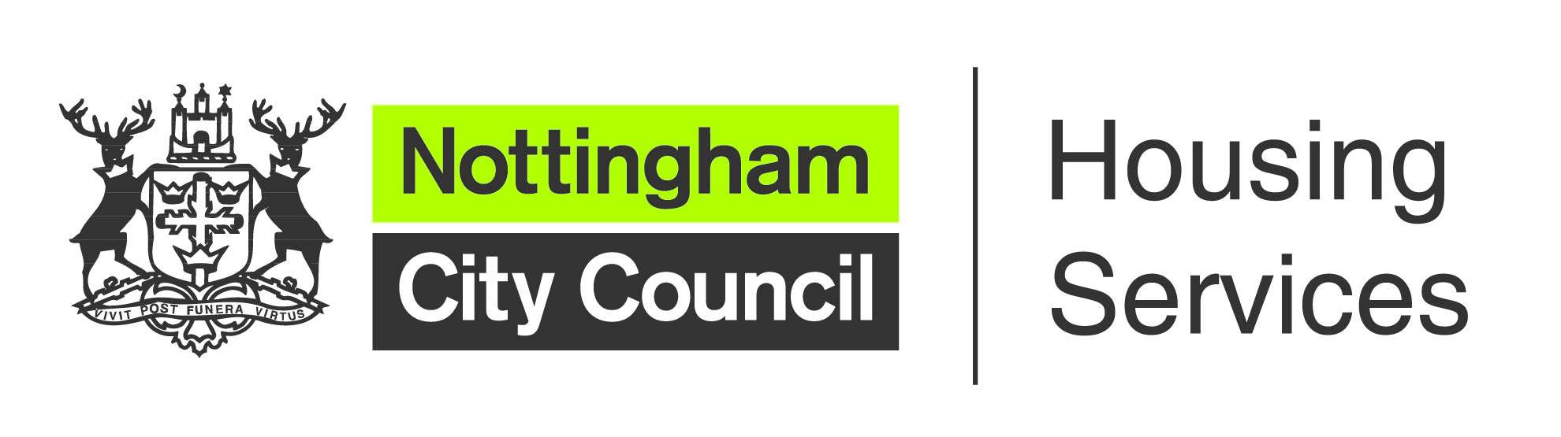

Garden Assistance Scheme application form

Conditions
To be eligible for the Garden Assistance Scheme, you must be a council tenant who subscribes to Nottingham City Council’s garden waste collection service. You must also be:

In receipt of one of the following:
- Personal Independence Payment
- Attendance Allowance
- Low level carers’ Disability Living Allowance
- High level mobility Disability Living Allowance

Or aged 70 or above and
- Have no-one living in your household who is not registered disabled
- Have no rent arrears over £500 (unless you’re on and keeping to a repayment plan)

If you meet one of the above conditions, please complete this form and return it to your local housing office with any proof of eligibility documents.

Your name
Your address
Your phone number
Your date of birth
Your email address

Reason for requesting assistance (including any medical information)

Proof of eligibility that you’re including with this application (such as information about attendance allowance or disability living allowance)

Name(s) and age(s) of anyone else who lives with you

Please note that if you fail to tell us about any change in your circumstances that may affect your eligibility for garden assistance, you will be taken off the scheme and may be recharged for any gardening work carried out at your home.

DECLARATION
I apply for garden assistance in accordance with the conditions, which I have read and which I understand.

Name
Signature
Date

Would you like to discuss moving to a more manageable home? Yes / No

FOR OFFICE USE ONLY – NOT FOR COMPLETION BY APPLICANT/TENANT

REQUIREMENTS
□ Full service
□ Hedges only

Tenant in receipt of:
PIP/Attendance allowance □ Yes □ No Evidence seen? □ Yes
Low level carers’ DLA □ Yes □ No Evidence seen? □ Yes
High level mobility DLA □ Yes □ No Evidence seen? □ Yes
Rent arrears less than £500/payment plan in place and kept to □ Yes □ No Evidence seen? □ Yes

I have carried out relevant checks and confirm the applicant meets the criteria for garden assistance.
Housing office
HPM
Contact number
Property ref. |  | Date
HPM - Please send completed application forms to gassis@nottinghamcity.gov.uk

